Bob’s Baked Beans
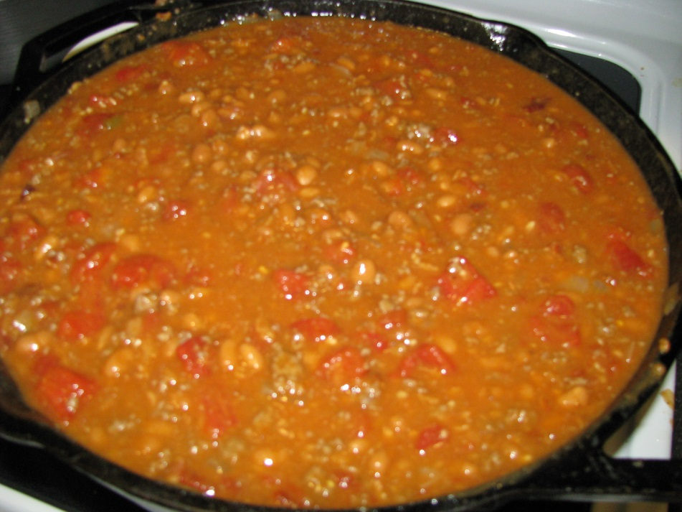
1 lb Hamburger (lean 20/80)
1 lb Bacon
1 Medium Onion
1 Cup Ketchup
1/3 Cup Yellow Mustard
80 to 110 ounces Bush’s Baked Beans - I adjust this depending if I increase the amount of hamburger and bacon I use. Sometimes I use more hamburger and bacon due to the size of crowd I am feeding.
3 Cans Petite Diced Tomatoes (14.5 oz. each)
1 Can Rotel Tomatoes w/ Habanero’s (10 oz.)
1 TBS Cumin (I always add extra cumin)
2 HEAPING TBS Minced Garlic
1 Cup Brown Sugar
Salt and Pepper to taste.
You will need a 6 to 7 quart kettle to make this. (I use a cast iron 7 ½ quart kettle)
Brown the hamburger with the chopped onion, salt and pepper to taste. Just before the hamburger is done, add the minced garlic for the last 2 to 3 minutes of browning the hamburger.
Cook the bacon separately until crispy and once it has cooled, crumble or cut into small pieces.
Add the bacon and all the rest of the ingredients to the hamburger, onion and garlic.
CRITICAL: Stir all ingredients together well, cover and refrigerate for at least 8 hours. This will give the ingredients time to meld together making the beans much more flavorful. These beans take a long time to make but you will find yourself going back time and again making them because people will request them.
You could bake these right away but I personally prefer to let them set overnight in a fridge.
Option would be to increase your hamburger and bacon from 1 lb. to 2 lbs. and increase the diced tomatoes and amount of beans slightly. All the other ingredient amounts should be fine. Again, season to taste.
Bake at 350 to 375 for one hour covered. Remove lid and cook an additional ½ hour uncovered.

