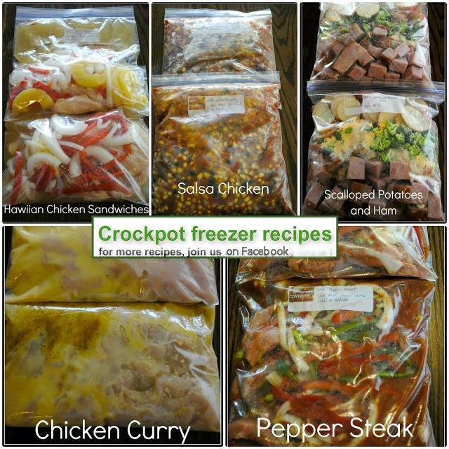
Crockpot Freezer Recipes- Fill your Freezer with these delicious Make ahead Crockpot Meals that are frozen until you need them, then you simply dump them into your slow cooker before you head out the door to work/play.**SHARE TO SAVE**
Hawaiian Chicken Sandwiches
6-8 Chicken Breasts (1 for each family member, doubled)
2 cups of chicken broth
2 small cans of pineapple rings
2 red bell peppers sliced into thin strips
1large onion sliced into strips
Provolone cheese
Whole wheat buns or lettuce wraps
Directions: Divide all contents evenly into two bags except cheese and buns/lettuce. Cook on low for 8 hours. Serve chicken topped with pepper and onions under melted provolone cheese on a bun or lettuce warp.
Savory Pepper Steak
3 pounds of roundsteak but into ½ inch thick strips.
½ cup flour
1 tsp of salt
1 tsp pepper
1 large onion chopped
a few garlic cloves—I like to put 4-5 crushed into each bag
1 green peppers sliced
1 red pepper sliced
2 16oz cans of tomatoes—I prefer Italian style
2 tbsp beef bouillon
4 tsp of Worcestershire sauce
2 tbsp of steak seasoning
2 tbsp of steak sauce
Directions: Toss steak strips in mixture of flour, salt and pepper. Mix together beef bouillon, Worcestershire sauce, and steak sauce and divide evenly into two bags. Add remaining ingredients. Cook on low 8 hours. Serve with rice and a side salad.
Scalloped Potatoes and Ham
12 WAXY potatoes, cut into ¼ inch round slices
2 cans of cream of whatever soup
2 cans of water
2 ham steaks, cubed
8 oz cheddar cheese
4 cups of broccoli
salt and pepper
Directions: Divide everything evenly into two containers. Cook on low for 8 hours.
Salsa Chicken
6-8 chicken breasts
2 15 oz. cans of black beans
1 family size frozen bag of corn
2 cans of diced tomatoes and green chilies
1 jar of salsa
1 packet of taco seasoning
2 cups of cheddar cheese
Directions: Divide everything except cheese evenly into two bags. Cook on low for 8 hours. Serve over rice or on corn tortillas with rice as a side.
Chicken Curry
4 chicken breasts (w/ rib meat)
2cans of cream of chicken soup
1cup of dry cooking sherry
½ cup of butter
8 green onions chopped
4 tsp of curry powder
salt and pepper
Directions: Divide everything except butter into two bags evenly. Add butter to crockpot when ready to cook. Cook on low for 8 hours. Serve over rice with a side salad.

